# Git and IntelliJ by Anuneet Rastogi

Explain the following questions in two simple sentences

1. What is the use of the git add command?
2. Write the command to create a branch “feature-group”.
3. What is a pull request? Write the steps involved in creating a pull request.
4. How do you add collaborators?
5. What is the command used to commit our changes in github repo?
6. Create a github account and repository to save all your assignment tasks. Example repository name: rg-assignments
7. Create a branch called feature-java(you can use it later to push all your java related tasks to this branch)
8. Install IntelliJ IDE. Create a simple java project displaying “Hello World!!”and share the screenshot.
9. In IntelliJ IDE, explore the shortcut keys for the following
   1. To run the project
   2. To select a line
   3. To comment/uncomment a line
   4. To delete a line

Answers:

1. It adds changes from your working directory to the staging area. This lets Git know which changes should be included in the next commit.
2. git branch feature-group
3. A pull request is a way to ask others to review and merge your branch into the main codebase. Steps: Push your branch, go to GitHub repo → "Pull requests" tab → Click "New pull request" → Select your branch → Click "Create pull request".
4. Go to your repository on GitHub → Click "Settings" → Select "Collaborators". Then add their GitHub usernames and send invitations.
5. git commit -m "Your message"
6. <https://github.com/Anuneet2003/rg-assignments>
7. git branch feature-java
8. 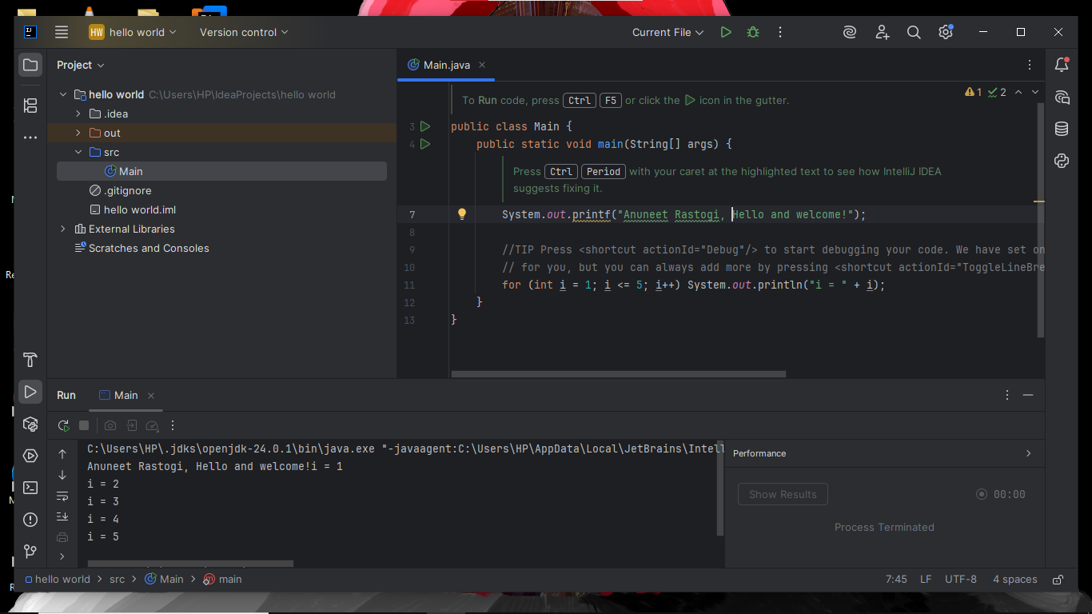
9. a. Run Project: Shift + F10

b. Select Line: Home then Shift + End

c. Comment/Uncomment Line: Ctrl + /

d. Delete Line: Ctrl + Y